**ANALOG TO DIGITAL CONVERSION**

**Digital Signal:** A digital signal is a signal that represents data as a sequence of discrete values; at any given time it can only take on one of a finite number of values. **Analog Signal:** An analog signal is any continuous signal for which the time varying feature of the signal is a representation of some other time varying quantity i.e., analogous to another time varying signal. The following techniques can be used for Analog to Digital Conversion:

**a. PULSE CODE MODULATION:**

The most common technique to change an analog signal to digital data is called pulse code modulation (PCM). A PCM encoder has the following three processes:

1. Sampling
2. Quantization
3. Encoding

**Low pass filter :** The low pass filter eliminates the high frequency components present in the input analog signal to ensure that the input signal to sampler is free from the unwanted frequency components.This is done to avoid aliasing of the message signal.

1. **Sampling –** The first step in PCM is sampling. Sampling is a process of measuring the amplitude of a continuous-time signal at discrete instants, converting the continuous signal into a discrete signal. There are three sampling methods: **(i) Ideal Sampling:** In ideal Sampling also known as Instantaneous sampling pulses from the analog signal are sampled. This is an ideal sampling method and cannot be easily implemented.**(ii) Natural Sampling:**Natural Sampling is a practical method of sampling in which pulse have finite width equal to T.The result is a sequence of samples that retain the shape of the analog signal.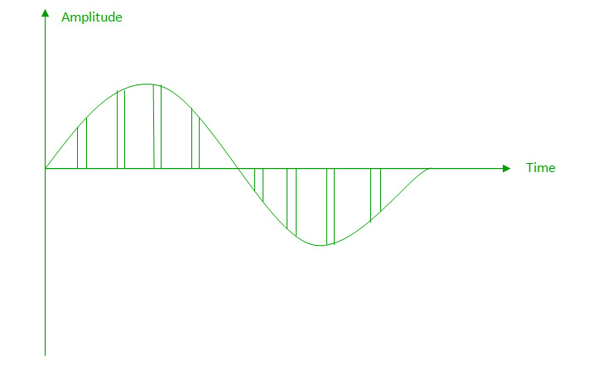**(iii) Flat top sampling:** In comparison to natural sampling flat top sampling can be easily obtained. In this sampling technique, the top of the samples remains constant by using a circuit. This is the most common sampling method used.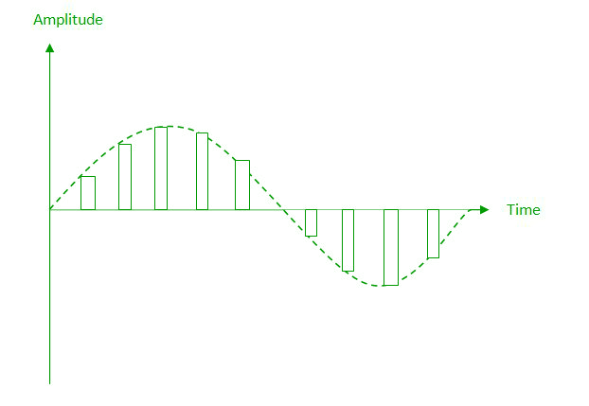**Nyquist Theorem:** One important consideration is the sampling rate or frequency. According to the Nyquist theorem, the sampling rate must be at least 2 times the highest frequency contained in the signal. It is also known as the minimum sampling rate and given by: Fs =2*fh
2. **Quantization –** The result of sampling is a series of pulses with amplitude values between the maximum and minimum amplitudes of the signal. The set of amplitudes can be infinite with non-integral values between two limits. The following are the steps in Quantization:
   1. We assume that the signal has amplitudes between Vmax and Vmin
   2. We divide it into L zones each of height d where, d= (Vmax- Vmin)/ L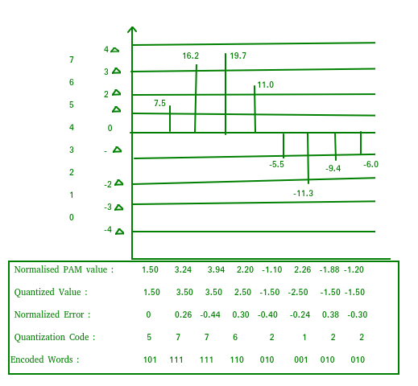
   3. The value at the top of each sample in the graph shows the actual amplitude.
   4. The normalized pulse amplitude modulation(PAM) value is calculated using the formula amplitude/d.
   5. After this we calculate the quantized value which the process selects from the middle of each zone.
   6. The Quantized error is given by the difference between quantized value and normalised PAM value.
   7. The Quantization code for each sample based on quantization levels at the left of the graph.
3. **Encoding –** The digitization of the analog signal is done by the encoder. After each sample is quantized and the number of bits per sample is decided, each sample can be changed to an n bit code. Encoding also minimizes the bandwidth used.  Note that the number of bits for each sample is determined from the number of quantization levels. If the number of quantization levels is L, the number of bits is n bit = log 2 L.

**b. DELTA MODULATION :**

Since PCM is a very complex technique, other techniques have been developed to reduce the complexity of PCM. The simplest is delta Modulation. Delta Modulation finds the change from the previous value. **Modulator –** The modulator is used at the sender site to create a stream of bits from an analog signal. The process records a small positive change called delta. If the delta is positive, the process records a 1 else the process records a 0. The modulator builds a second signal that resembles a staircase. The input signal is then compared with this gradually made staircase signal.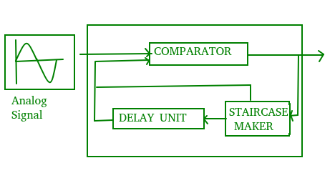We have the following rules for output:

1. If the input analog signal is higher than the last value of the staircase signal, increase delta by 1, and the bit in the digital data is 1.
2. If the input analog signal is lower than the last value of the staircase signal, decrease delta by 1, and the bit in the digital data is 0.

**Demodulator** – The demodulator takes the digital data and, using the staircase maker and the delay unit, creates the analog signal. The created analog signal, however, needs to pass through a low-pass filter for smoothing.

**c. ADAPTIVE DELTA MODULATION:**

The performance of a delta modulator can be improved significantly by making the step size of the modulator assume a time-varying form. A larger step-size is needed where the message has a steep slope of modulating signal and a smaller step-size is needed where the message has a small slope. The size is adapted according to the level of the input signal. This method is known as adaptive delta modulation (ADM).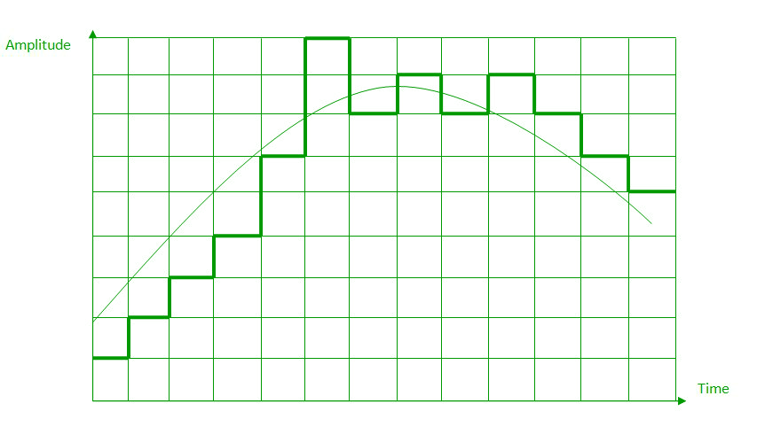

**Digital to Analog Conversion**

**Digital Signal –** A digital signal is a signal that represents data as a sequence of discrete values; at any given time it can only take on one of a finite number of values.

**Analog Signal –**An analog signal is any continuous signal for which the time varying feature of the signal is a representation of some other time varying quantity i.e., analogous to another time varying signal.

The following techniques can be used for Digital to Analog Conversion:

**1. Amplitude Shift keying –** Amplitude Shift Keying is a technique in which carrier signal is analog and data to be modulated is digital. The amplitude of analog carrier signal is modified to reflect binary data.

The binary signal when modulated gives a zero value when the binary data represents 0 while gives the carrier output when data is 1. The frequency and phase of the carrier signal remain constant.  
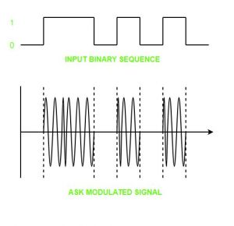

**Advantages of amplitude shift Keying –**

* It can be used to transmit digital data over optical fiber.
* The receiver and transmitter have a simple design which also makes it comparatively inexpensive.
* It uses lesser bandwidth as compared to FSK thus it offers high bandwidth efficiency.

**Disadvantages of amplitude shift Keying –**

* It is susceptible to noise interference and entire transmissions could be lost due to this.
* It has lower power efficiency.

**2. Frequency Shift keying –**In this modulation the frequency of analog carrier signal is modified to reflect binary data.

The output of a frequency shift keying modulated wave is high in frequency for a binary high input and is low in frequency for a binary low input. The amplitude and phase of the carrier signal remain constant.  
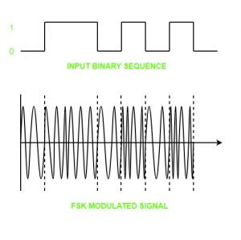

**Advantages of frequency shift Keying –**

* Frequency shift keying modulated signal can help avoid the noise problems beset by ASK.
* It has lower chances of an error.
* It provides high signal to noise ratio.
* The transmitter and receiver implementations are simple for low data rate application.

**Disadvantages of frequency shift Keying –**

* It uses larger bandwidth as compared to ASK thus it offers less bandwidth efficiency.
* It has lower power efficiency.

**3. Phase Shift keying –**In this modulation the phase of the analog carrier signal is modified to reflect binary data.The amplitude and frequency of the carrier signal remains constant.

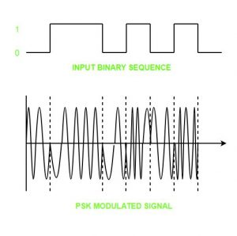

It is further categorized as follows:

1. **Binary Phase Shift Keying (BPSK):**  
   BPSK also known as phase reversal keying or 2PSK is the simplest form of phase shift keying. The Phase of the carrier wave is changed according to the two binary inputs. In Binary Phase shift keying, difference of 180 phase shift is used between binary 1 and binary 0.

This is regarded as the most robust digital modulation technique and is used for long distance wireless communication.

1. **Quadrature phase shift keying:**  
   This technique is used to increase the bit rate i.e we can code two bits onto one single element. It uses four phases to encode two bits per symbol. QPSK uses phase shifts of multiples of 90 degrees.

It has double data rate carrying capacity compare to BPSK as two bits are mapped on each constellation points.

**Advantages of phase shift Keying –**

* It is a more power efficient modulation technique as compared to ASK and FSK.
* It has lower chances of an error.
* It allows data to be carried along a communication signal much more efficiently as compared to FSK.

**Disadvantages of phase shift Keying –**

* It offers low bandwidth efficiency.
* The detection and recovery algorithms of binary data is very complex.
* It is a non coherent reference signal.

**Reference –**  
[Digital-to-analog converter – Wikipedia](https://en.wikipedia.org/wiki/Digital-to-analog_converter)